# Abstract

**Dental Clinic management system** is a web-based application which is made for the treatment of teeth issues from child-ageing. Here, patients can find all the information regarding to their issues. Admin will provide all the details knowledge about the clinic. User can book the appointment if they feel likable about the clinic. All the booking name will be viewed by admin in admin dashboard.

Here in the system:

User can book the appointment.

Admin can edit, delete patient profile.

Admin can edit, delete doctor profile.

Admin can view all the list of the patient booking.

User can ask the question in contact us page for enquires.

User can view the doctor profile in home page.

# Acknowledgment

I would like to thank all those people who support me to complete a project. Without teacher and my beloved friends, my project is never going to happen. This project is successful with the help of my teacher **Mr.Niman Maharajan** who always help and encouragement me in a class while I’m doing research for my project. He provides me proper guidance and knowledge about my project during research from internet. He helps me in composing while my code has been failed and have shown many bugs during implementation. I would also like to thank **Mr. Sudeep Lal Bajimaya** who helps to me to remind when I forget requirements in my project and also help to find mistake. This project wouldn’t be success without support and proper guidance. For the encouragement and fully support about my project. I’m so thankful to my friends, family and teachers.

# Chapter1-

# Introduction

Nowadays, most people from child-ageing are suffering from teeth issues. By recognizing this issues, I have thought to make my project about dental clinic management system. Here, all dental services treatment will be provided to patients for their betterment. First of all, patients details will be recorded, details of treatment and which doctor has been treated to patients will be also be recorded .DCMS records all the details of the clinic and helps to solve the problems of patients. To make this project success, I have used **PHP** for programming, Laravel framework and my **SQL** for database.

## Background of the project

In today’s world, many organizations uses old recording system. They did work manually. Patients have to wait a long time for appointment and also consult with doctor.

## 

## Overview of the project

This project has been created to give better treatment to patients and improve their oral health by consults with experience dental doctors. This project will not consume too much time of patients and through online they can see all the features and treatment process. There will be more security.

## Features

The features of my project are is there are two type of actor **User** and **Admin.**

CRUD functions is carried by users. Here, is also online process where user can book an appointment. These are the following are the features that user can see:

* **Previous treatment history can see by User.**
* **Different types of treatment that has been treated on clinic can also see by User**
* **Admin can connect videos about treatment methods.**
* **Admin can add the doctor name and patients can view the doctor while booking in homepage.**
* **User can see all the detailed information about clinic.**
* **User can contact if they have to know a detailed information about clinic.**

## 1.4 Aims

The main aims of this project are:

* Reducing human efforts.
* To provide better functionality.
* Avoiding Data redundancy of the patients.

## 1.5 Objectives

* To retrieve patients history.
* Promoting Business services for upcoming days.
* Update and upgrade existing system.
* To reduce manual work.

# Chapter- 2

# 2.1 Introduction to analysis

Most important phase of SDLC called analysis which is used to build a project. It is a part of project where we have to identify what is the project strategy? And the direction of a project. Analysis is a description of all aspects of the current system and also existing problems. Analysis structured all the requirements of information system.

The following are the activities which are involved in analysis:

1. Firstly, we have to identify what is the need of project?
2. We have to evaluate a system for feasibility.
3. Economic and technical analysis should be performed.
4. We have to establish a schedule.
5. System definition should be created.

Analysis is performed for making a decision and also for problem solving. If we did analysis, we can achieve goals and objectives for a project. Analysis will identify the problems why things have not worked. It will be focused on solution rather than seeking blame. Analysis is also done to improve your work. For change, analysis share understanding and ownership of decisions.

**PEST ANALYSIS:** Political, economic, sociological and technological issues are analyzed by this method. It also assessed the effects of legal and environmental issues in an organization. Knowledge of management, marketing and organization growth and decline is also can be understand by PEST.

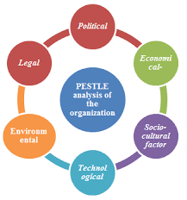

Figure 1: Pest analysis

**Political:** political influence on an organization such as environmental and legal issues can be assessed by using political factor. In my project, environment mayn’t be suitable to complete a project.

**Economic**: local, national global influence like recession, economy situation and trends can be assessed by using economic factors. There are lots of economic factors that occurs during my project. Trends will be changes and maybe my project will not be fruitful according to the trends.

**Sociological:** It assess ways in which a society can influence on an organization such as lifestyle, advertising and publicity etc. In a project, there should be so much advertisement and publicity. By doing this, my project will be known.

**Technological:** Impact of new technology on an organization such as rapid development, non-compatibility can be accessed by using this factor. My project will be affect by this factors because technology has been developing rapid day by day.

Example of pest:

* For developing a competitive strategy.

**CATWOE ANALYSIS:** It is a part of soft system methodology used to recognize the achievement of the project. Analyzed information system is used to group all the people, processes and external factors (Business Change Academy, 2017). CATWOE stands for:

**C**= customers/clients  **W**= world view

**A**= actors/agents  **O**= owners

**T**= Transformations **E**= environment

**Customer:** They are stakeholder for whom the system exists. In this step, system gets benefits by changing process. This is the first step that identify a customer and understanding how the system affects them. In my project, customer is patients. They can login to see the detailed information about clinic.

**Actors:** actors or agents are directly involved with the system. For implementation of changes in the system, these people are involved. Actors means admin, receptionist and dentist in my project. Their role is according to the organization.

**Transformations:** This step is called changes step where the process bring about. It describes what processes will be affected by development of the system. There are lots of transformation in my project such as: patients can book appointment for checkup. In past years, there is no any functions like this. So, by this transformation time will be save.

**World View:** worldview identify how the development of system influences all around the organization. It also explain the transformation of system. By staying every corner of world, people can research about this clinic and get to know many information through internet.

**Owners:** owners are the decision maker who have authority to make the changes decide how to run a project in a future. Owners will be only one in my project i.e. admin. Admin can update and handles any kinds of information of clinic.

**Environment**: environment is one of the most important phase. We have to know the social, economic issues for developing a project. We have to investigate what will be affect for a project. Examples are: regulations, financial constraints etc. There should be good environment to do any work. If my clinic project environment is good, many patients will came to checkup.

# 2.2 Feasibility Study

Feasibility study is an analysis which is used to measure the ability for completing a project successfully by including all necessary factors. It aims is to know all the strength, weaknesses, opportunities and threats that are present in a project. A well-designed feasibility study describe the details of operation, management and policies of a project. The main objectives of feasibility study is to understand all the concepts, plan and aspects of a project and should be alert of potential problems that could occur while implementing the project.

Feasibility study is divided into four parts:

1. **Economic feasibility**: It concludes that skillful software can generated financial gains of an organization. It focus on issues like cost of hardware, software and training.
2. **Technical feasibility:** Recent resources like (hardware, software) and technology are assessed by this feasibility to accomplish user requirement within allocated time and budget. There should be update and upgrade of resources and technology. In this feasibility, relevant technology is performed which are established and stable.
3. **Schedule feasibility:** This means that the project have to be completed within scheduled time limits. To control the schedule feasibility, project have to complete on time and there will not be a loss of utility. GANTT CHART is an example of schedule feasibility.
4. **Operational feasibility:** This feasibility is highly dependent on human resources. To solve the business problems and user requirements it assessed software performance step by step. In this feasibility, tasks like suggested solution by the software development team acceptable is determined.
5. **Legal feasibility:** This feasibility concludes that every proposed system should be comply with legal environment.

# 2.3 Requirement analysis

SDLC essential phase is also the requirement analysis which determines user expectation for a new or modified product. Firstly, we have to identify what the user want or expectations from a project. Then a system is made according to user requirements.

Requirement analysis includes:

1. **Focus groups:** Here, question can be used to gather data from several sources at one time.
2. **Observation:** It is a direct method of collecting information. Problems can be easily identify. There is an involvement of users.
3. **Documentation:** It is a good source of development and can clarify the understanding.

# Functional Requirements

Functional requirements relates to the technical and behavioral functionality of a system. It identify what system should be during a project.

* The following points are the functional requirements.

|  |  |
| --- | --- |
| **Functional ID** | **Title** |
| F1 | Register |
| F2 | Login |
| F3 | Help |
| F4 | Contact Us |
| F5 | Update patient profile |
| F6 | Book Appointment |
| F7 | Blog |
| F8 | Delete Blog |
| F9 | Add Patients |
| F10 | Update Patient |
| F11 | Delete Patient |
| F12 | Add Doctor |
| F13 | Update Doctor |
| F14 | Delete Doctor |
| F15 | Add Category |
| F16 | View Appointment List |
| F17 | View Doctor List |

# Non-functional Requirement

Non-functional requirements mainly focused on operation of a system in a particular condition rather than specific behaviors. It mainly focus on how system performs on a project? And specify the attributes or characteristics of system quality.

The following points are the non-functional requirements:

|  |  |
| --- | --- |
| **Non-Functional ID** | **Title** |
| F1 | Usability |
| F2 | Data Integrity |
| F3 | Security |
| F4 | Maintainability |
| F5 | Availability |
| F6 | Performance |
| F7 | Efficiency |
| F8 | Accuracy |
| F9 | Extendibility |
| F10 | Robustness |
| F11 | Ease of use |

# 2.3.3 Moscow prioritization

The special techniques for managing requirements and prioritizing for understanding is called Moscow prioritization. It stands for:

**Must Have:** essential, without it there is no any solution.

**Should Have:** It means applied if at all possible.

**Could Have:** less important but not critical.

**Won’t Have:** not needed today, but may be applied in future project.

|  |  |
| --- | --- |
| **Requirement** | **Moscow** |
| R1. Register | Must Have |
| R2. Login | Must Have |
| R3. Book Appointment | Must Have |
| R4. Confirm password | Must Have |
| R5. View Profile | Could Have |
| R6. Add Patient | Must Have |
| R7. Update Patient | Must Have |
| R8. Contact Us | Should Have |
| R9. Help | Should Have |
| R10. Newsletter | Should Have |
| R11. Data Integrity | Could Have |
| R12. Performance | Could Have |
| R13. Blog | Should Have |
| R14. Online Chat | Won’t Have |
| R15. Category | Must Have |
| R16. Availability | Could Have |
| R17. Add Doctor | Must Have |
| R18. Update Doctor | Must Have |
| R19. Delete Doctor | Should Have |
| R20. Security | Should Have |
| R21. Maintainability | Could Have |
| R22. Reliability | Could Have |

# SRS

SRS stands for software requirement specification which described all the detailed about software system to developed by containing both functional and non-functional requirements. Agreement between client and developer is necessary for this system to meet the client’s requirement. All the necessary documents for a project is provided by SRS.

**Software requirement**

**Database:** MYSQL

**Programming Language:** PHP

**UI Design:** HTML, JQUERY, JAVASCRIPT

**WEB Browser:** Google chrome, Opera, Mozilla

**Software Used:** XAMPP Server

**Hardware Requirement:**

**OS:** Windows 10 Pro 64 bits

**Memory:** 4GB RAM

# 2.4 Use case

Use case is a static model figure that is used to identify and organize system requirements. It demonstrates the connection among clients and diverse use cases in which client is included. The following are the characteristics of use case:

1. It systematized functional requirements.
2. It shows the interaction between system/actors.

**Symbols of use case:**

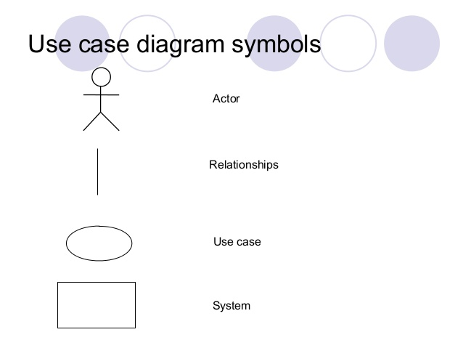

Figure 2: Use Case Symbols

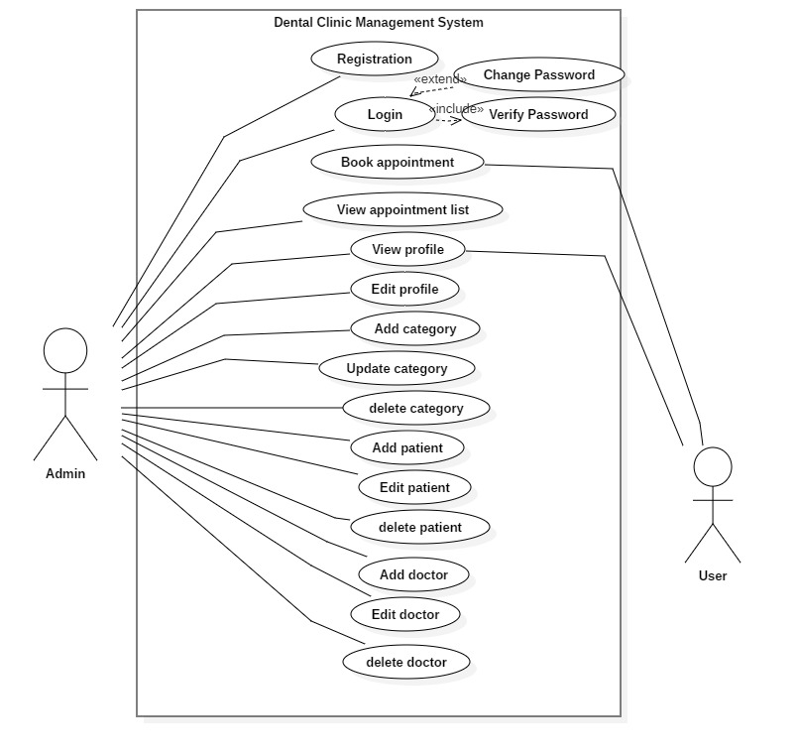

Figure 3: use case diagram

In this above diagram, there are two actors. i.e.  **Admin** and **User.** Admin can register and login. here, we can see admin can View appointment list, View profile, Edit profile, Add category, Update category, delete category, Add patient, Update patient, delete patient, Add doctor, Edit doctor, Delete doctor. At another point, user can book the appointment, view their own profile.

# 2.5 Initial class diagram (NLA)

**Natural Language Analysis:**

To identify nouns, verbs and adjective from a scenario or illustrative text which is known as NLA. In this method noun is linked to candidate classes, verbs is related to functionality or candidate operation and adjectives is related to attributes. After finding this, we have to list out a duplication, synonyms, and irrelevancies from a scenario to obtain final candidate classes.

|  |  |
| --- | --- |
| **Nouns** | **Verbs** |
| Nowadays, Businesses, Institutions, system, receptionist, space, time, paper, patient, information, clinic, Dental aide, name, age, gender, treatment, dentist, admin, user, patients list, Manually, Problem, Computerized, Responsible, Master list, Procedure. | Done, still using, still experiencing, consumes, find, store, need, ask, will undergo, identify, add, delete, update, login, register, book appointment, produce schedule, update patients detail, view, provide printed copy, create perspective |

* **Final Candidate classes (noun) are:**

Patient, Dentist, receptionist, Procedure.

* **Final candidate operations(verbs) are:**

Login, register, add, update and delete, book appointment, produce schedule, create perspectives.

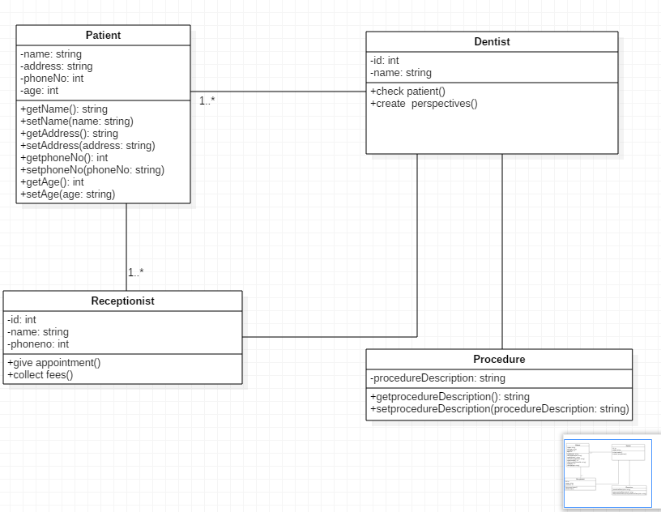

Figure 4: Initial Class diagram of dental clinic

# Chapter- 3

# Design

Design is the period of planning and also called framework which is done after gathering the user requirement and analyzing the system to make a project more reliable. Design is a development that is in the form of prototype. Firstly, we did design on a paper or design tool and then implemented in the system by using various tools, techniques and models. Design is important to make a user more easily understood and convenient.

To implement the various user requirement in the software, I have used various design models such as structural and behavioral models. Structural models is used to show the structure of a system and behavioral model is used to show the workflow of a system being developed. Rather than this, I have used database design which includes data dictionary and ER diagram. To give overview as how the system backend and frontend would be like I have done user interface design.

# Structural design

System static features can viewed by structural design. It represent the framework for a system where all the components are exists.

# Class diagram

Class diagram is a static diagram which is used to show the system static view. It is used mainly for constructing executable code of software rather than describing, visualizing different aspects of a system. Class is a blueprint of an object which shows the structure of a system.

**Why we used class diagram?**

1. System responsibilities can be described.
2. It depicts the system framework by representing the system classes, their attributes, operations and relationship among the object.

**Notations**

* useable notation of class diagram are:

Name of class



Attributes

Operations

1. Inheritance
2. Association

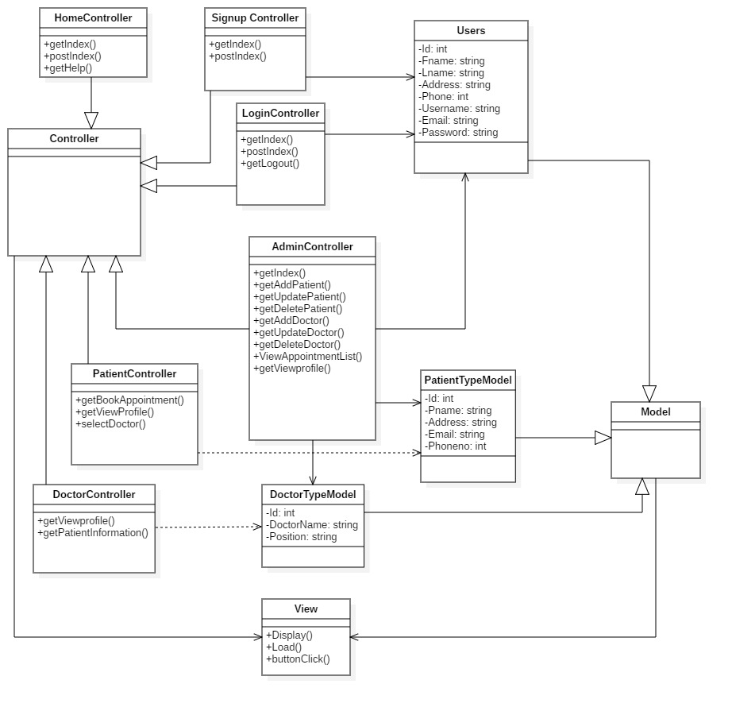

Figure 5: class diagram

Class diagram represents the structure of a system. For controlling a whole system, model is used to manipulate the data. To access the data, view is used through controller. This above class diagram is followed by MVC design pattern which includes model, view and controller.

# Dataflow diagram

Dataflow diagram is a way of representing a flow of a process or a system. It delivers information about each entity outputs and inputs and the process itself. There are only one rule in DFD i.e. all the flow must be start with and end at a processing step.

DFD is easy to understand the flow of data through the system.

* **Why we used data flow diagram?**

1. There is a good interaction between user and system designer.
2. Flow of system will be logical for the information.

**Notations**

The following are the notations used in data flow diagram.

1. External entities
2. Process

1. Data store
2. Data flow

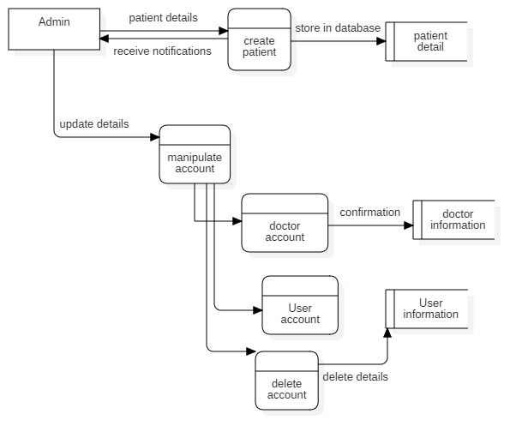

Figure 6: Admin DFD

Admin store patient details in the database. Admin can update all the manipulate account that is involved in dental clinic management system. i.e. Admin can update doctor account and store all the information in dentist information database. Admin can update User account and store all the information in user information database. Admin can delete all the account.

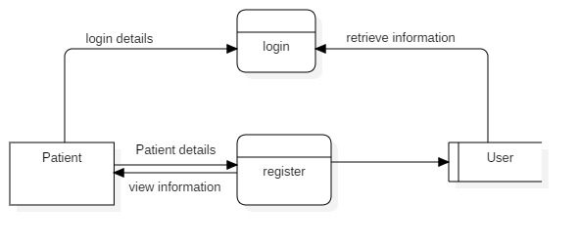

Figure 7: DFD (registration, login)

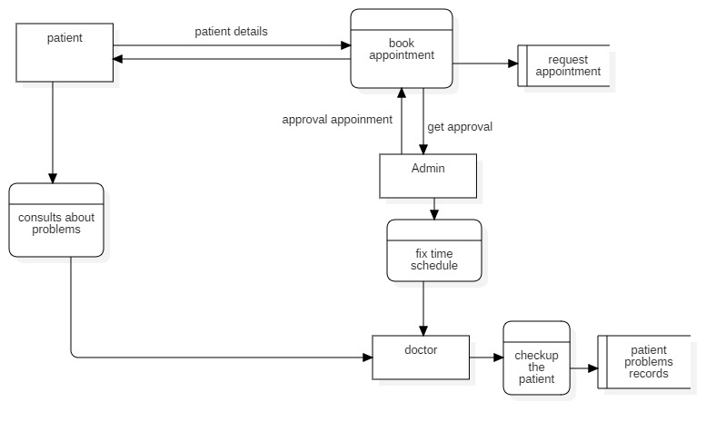

Figure 8: process of DFD

After, patient login to the system. Then, patient book the appointment by the help of receptionist where patient has to include all the details and this record will be store in database. Then, receptionist gives approval to the patient. On the other hand, Admin fix a time schedule. Then, patient consults about their problems to the doctor. Doctor check the patient and all the patient problems record will be store in database.

# Behavioral design

Behavioral design is a sub-classification of plan, which is worried about how configuration can shape, or be utilized to impact human practices. It shows the interaction within the system.

# Activity diagram

It is a figure in UML which explains the whole system about dynamic aspect. Activity diagram is basically a flow chart to represent the flow from one activity to another activity. It also describe as an operation of a system. Activity diagram also called work flow diagram. It describes all the logic of the operation which are exhibits on class diagram.

* **Why we used activity diagram?**

1. Dynamic aspect of a system is taken.
2. Parallel, branched and concurrent flow of the system is explained by this diagram.

* **Notation**

The following are the most useful notation:

1. Start
2. Action
3. Basic flow
4. Decisions

1. End

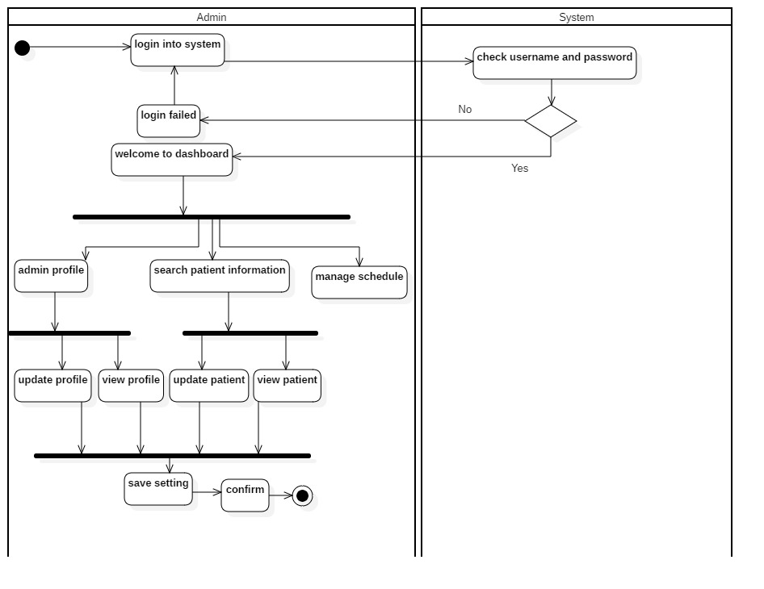

Figure 9: Activity diagram 1

Firstly, admin login to the receptionist system. Then, check the username and password. If username is valid, then directly goes to dashboard. If invalid then again return to login page. After successfully login, admin can see the profile, search patient information and seeing the manage scheduling. Admin can update, view the profile of the patient. At the end admin save the setting and click on confirm then the admin profile is terminated.

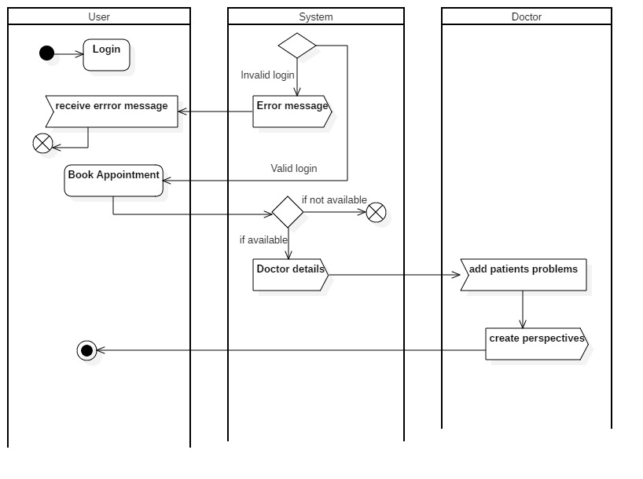

Figure 10: Activity diagram 2

Here, User login to the system. Then, system check the username and password. If valid then, patient or user can book the appointment. If invalid, then error message is seen. After booking the appointment, patient or user check the doctor details in the system. Then, doctor add the patient problem and create perspectives. After that, system gives the acceptance time event. At last, patient profile is terminated.

# Sequence diagram

It is the popular dynamic modelling solution in UML. It focus on lifelines or the process and object that lies concurrently and the message exchange between them to perform or function before lifeline ends. It describes object relationship and interaction between themselves.

* **Why we used sequence diagram?**

1. It consists of no of lifelines that produces message which make user easy to understand.
2. It shows dependencies of objects and methods but not usually implemented directly.

**Notation**

The following are the notation used in sequence diagram:

1. **Lifeline**

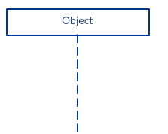

1. **Message**

1. **Reply message**



1. **Self-message**



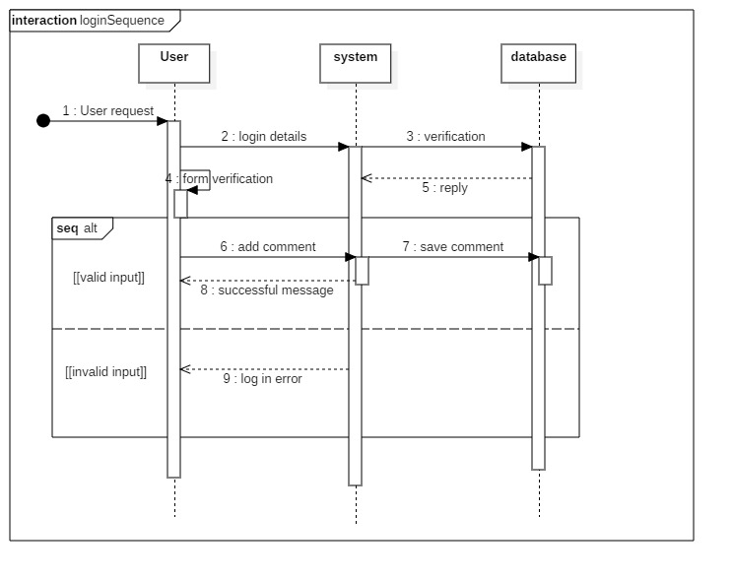

Figure 11: Login sequence diagram

Here, User login to the system. For verification, system sends to database and system itself form verification. The system valid information is directly stored in a database. If invalid, then the message is directly goes to the login page.

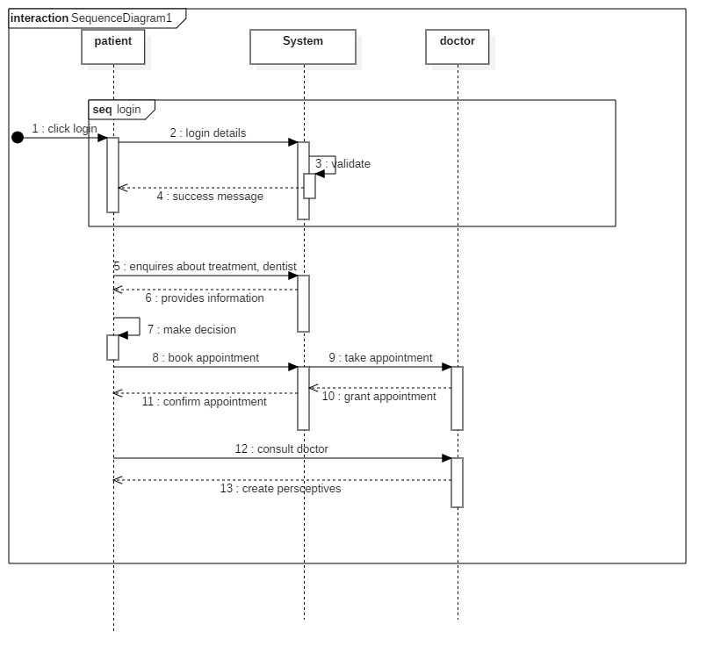

Figure 12: Sequence diagram of flow system

After login, patient send enquires message to system for verification. Then, system provides information in the reply. Patient make decision and book the appointment. After that, system take appointment to doctor and doctor grant appointment to system. For confirmation, system reply message to patients. Then, patient consults with doctor and doctor create perceptive to patient.

# Database design

Database design is the process of organizing a data in the basis of database model. It is method of managing a data in a database system also used to remove data redundancy.

# Data dictionary

Data dictionary is a process which database keeps data about its own structure. It is used to control access to and manipulation of the database. Metadata is kept in data dictionary. It describe the format and structure of database.

* **Dentist Table**

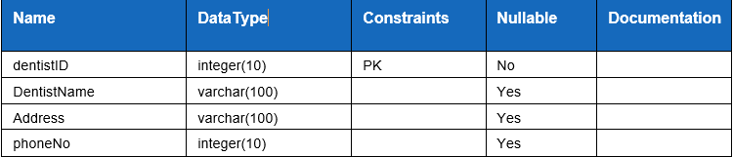

* **Patient Table**

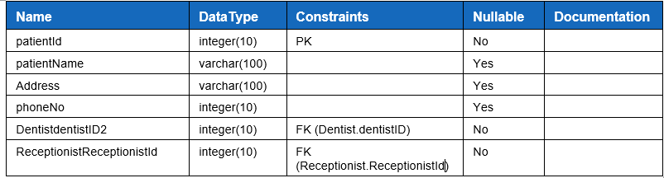

* **Medicine Table**

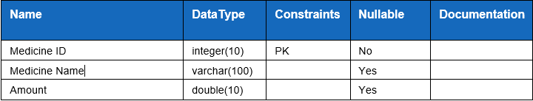

* **Receptionist Table**

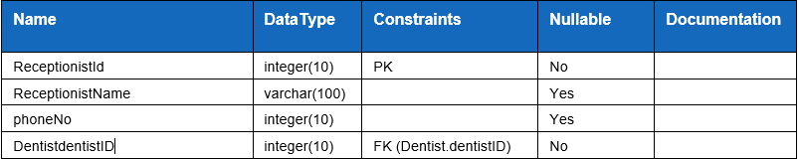

* **Bill Table**

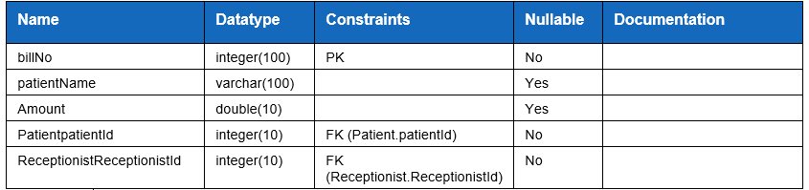

# Entity Relationship Diagram

ER diagram characterize the relationship between entities that is stored in a database. It is a logical structure of a database. Also, there will be defining the entities, their attributes in ER diagram. CROWS FEET, UML or CHEN notation are the ways in which ER diagram can be represented.

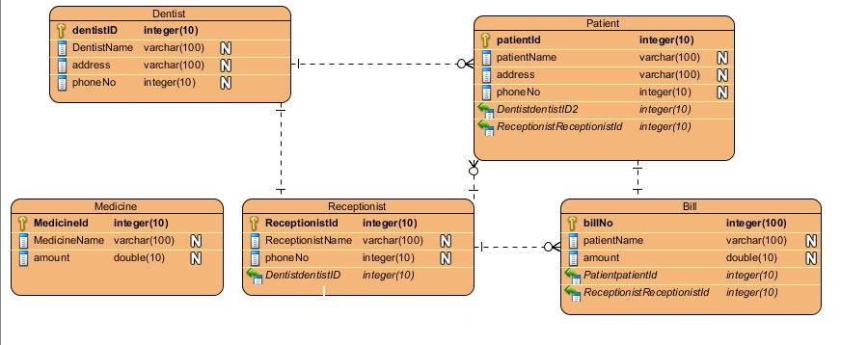

Figure 13: ER diagram

In this figure, there are five entities. This diagram is based upon data dictionary. Entity dentist has one-to-many relationship with patient. Likewise, dentist has one-to-one relationship with receptionist. Whereas, receptionist has one-to-many relationship with bill entity. On the other hand, patient has many-to-one relationship with receptionist. Again, patient has one-to-one relationship with bill entity.

# UI design

UI design means interaction of users with design which focus on style while creating interfaces in software. UI design aims is to create a design where users can easily understood, use efficiently. User experience and usability is mainly focus for increasing in UI Design.

* There are three rules in UI design:

1. User controls should be place in order.
2. Memory load of users should be reduce.
3. Making interface consistent.

# 3.4.1 Prototype

Prototype is used when users is unclear about the requirements. It is an easy way to understand about the details of input, process and output needs of the software. Prototype is a working model which doesn’t consider all the features but provides all the system functionality to the users.

* Home Page

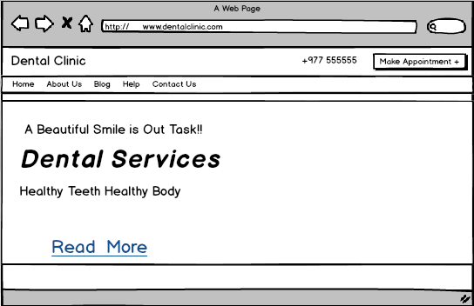

Figure 14: Prototype of homepage

* Admin registration page

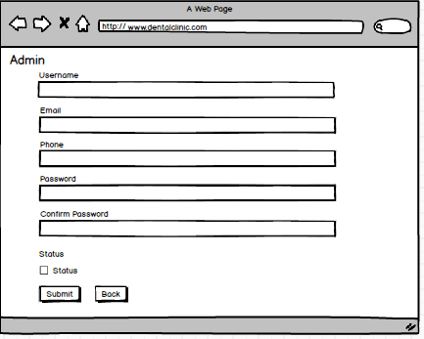

Figure 15: Admin Registration prototype

* Admin Login Page

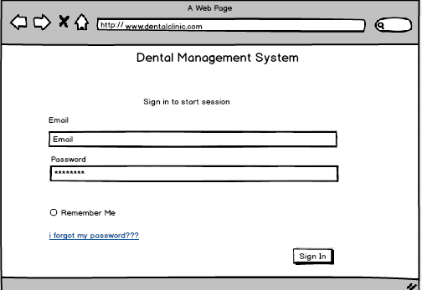

Figure 16: Prototype of sign in

* Dashboard Page

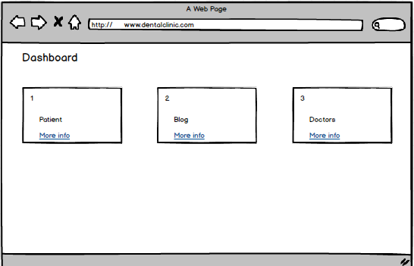

Figure 17: Prototype of dashboard

* Doctor adding page

# 

Figure 18: Add doctor prototype

* Doctor List Page

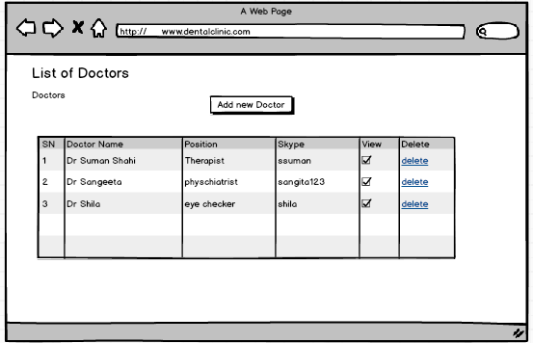

Figure 19: Doctor List prototype

* Blog Post Page

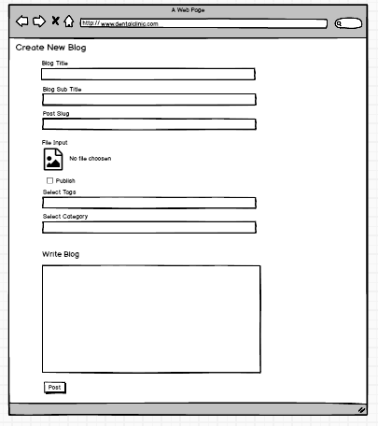

Figure 20: Blog post prototype

* Blog details page

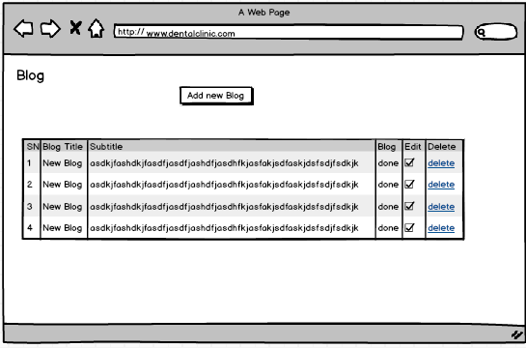

Figure 21: Blog details prototype

* Users List Prototype

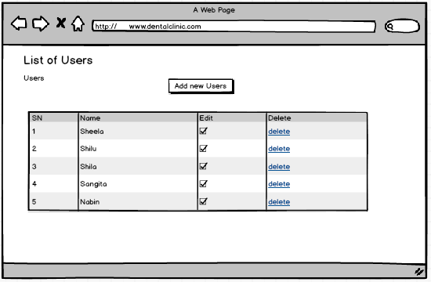

Figure 22: Users list prototype

# Chapter-4: Implementation

## 4.1 Introduction

Implementation is the 3rd Phase of software development lifecycle. Coding is the process which is done based upon analysis and design. After planning the features and functionality the real working system is done in the phase of coding and also gathering the requirement specification, this phase is build a new product in software by using various tools and techniques.

## 4.2 Coding Language

To construct the framework we need to pick one programming language. Among numerous languages I rise toward PHP. It represents Hypertext preprocessor; it is a server side language utilized by web engineers to keep up the back end of the framework. This language move the information from front end to the database. I choose PHP in the fact that it is appropriate for creating online or web applications.

## 4.3 Framework

The structure or framework utilized while building up the application is Laravel. It follows Model-View controller design to build up the online applications. Following are the advantage utilizing laravel:

* It is used for creating authorization and authentication system.
* It makes web apps faster by integration with tools.
* It handles configuration error.
* Features of composer is available in laravel.

For keeping up the database, I have utilized MySQL. It is used to communicate with database.

## 4.4 Tools used

## 

I have used following tools for system implementation:

1. For editing code, I have used **PHP storm.**
2. For running and also scripts testing, **google chrome** is used.
3. For hosting a server, Xampp is used.

**Note:** The screenshot of the code is in the appendix section.

# Chapter 5: Testing

## 5.1 Introduction

A strategy which is finished during the advancement procedure called testing. It additionally measure item quality. Here, necessity need to meet and functions true to form result. To distinguish the contrasts between given information and anticipated yield, testing is utilized.

## 5. 2 Importance

The following points are the importance of testing:

1. It is a steady framework and easy to use.
2. It is utilized to discover bugs and furthermore imperfection of the framework.
3. It saves money.

## Types of testing

1) Black-Box Testing.

2) White-Box Testing.

3) Unit Testing.

4) Regression Testing.

5) Acceptance Testing.

6) Integration Testing.



## 5.4 Black-Box Testing

Black-Box testing is a software testing which don’t peered with internal structure, only observes application functionality. Software system input and output is only focused by this testing.

Following are the test plan for the Black-Box testing.

1. **Checking validation of empty registration.**

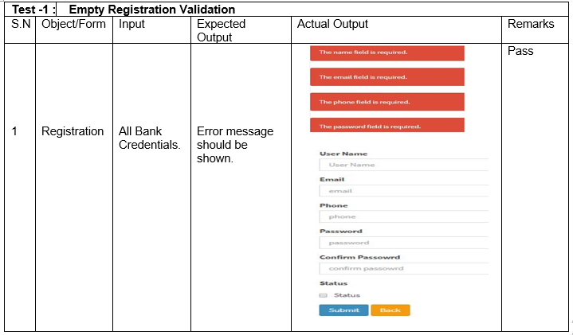

1. **Checking validation of email.**

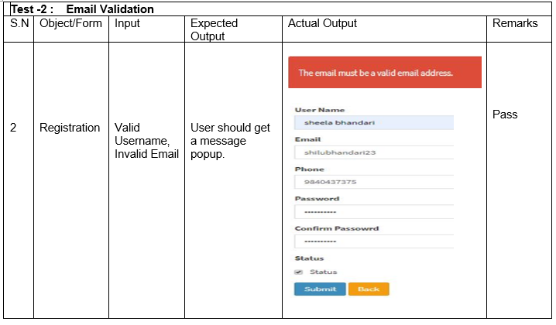

1. **Mismatching Password.**

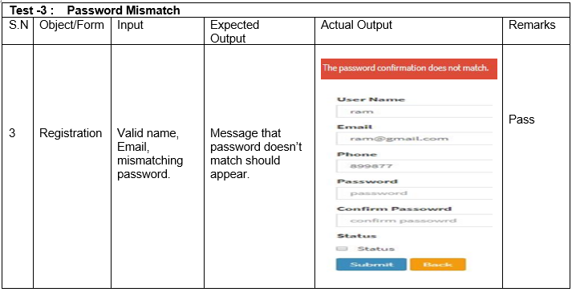

1. **Validation of password length**

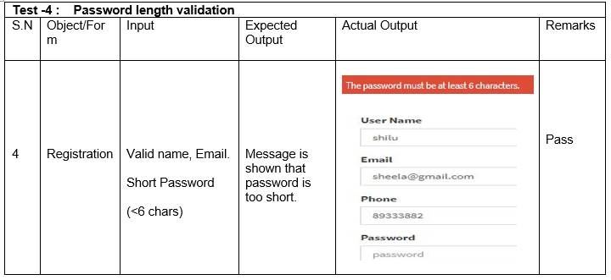

1. **Register**

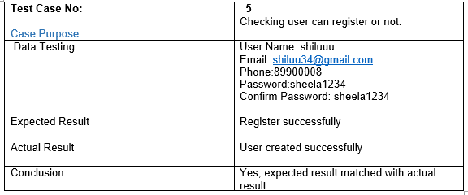

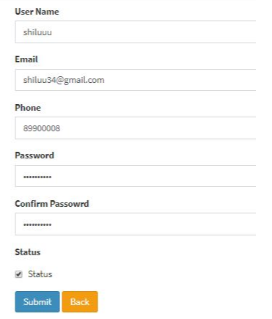

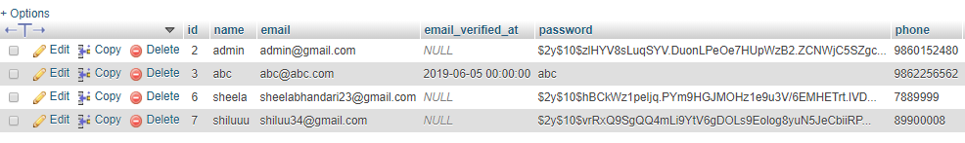



1. **Email and password checking.**

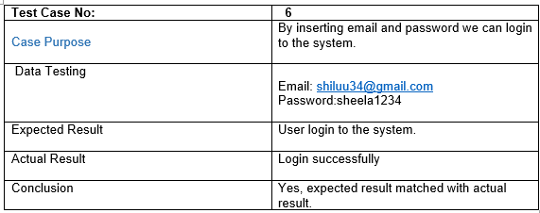

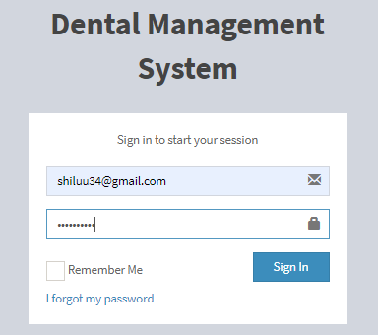

1. **Admin login successful.**

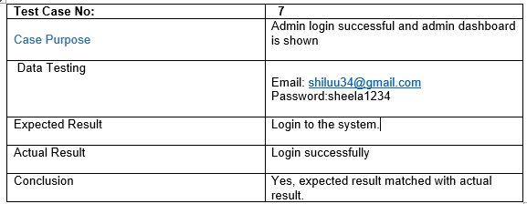

* **Dashboard page**

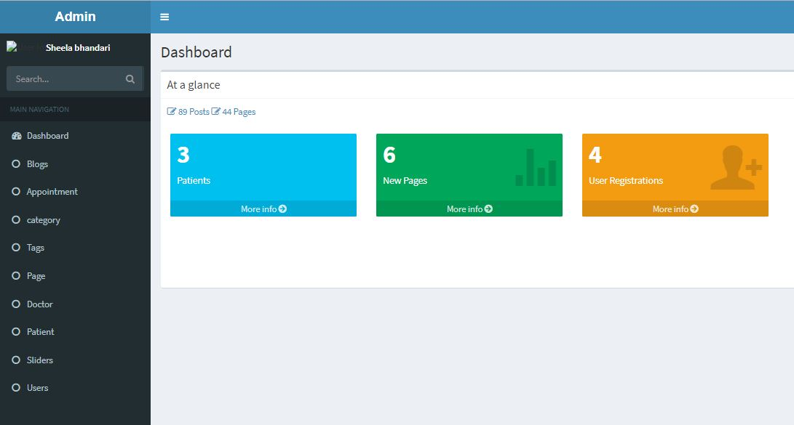

1. **Checking invalid credentials.**

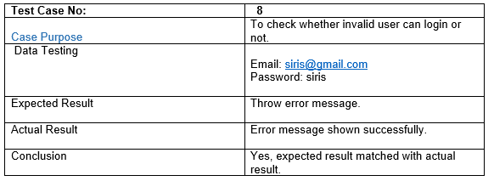

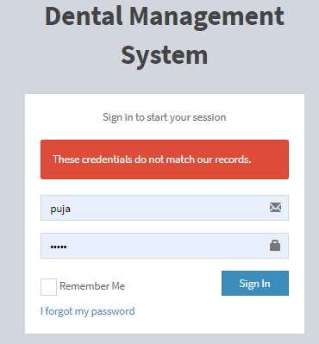

1. **Add patient**

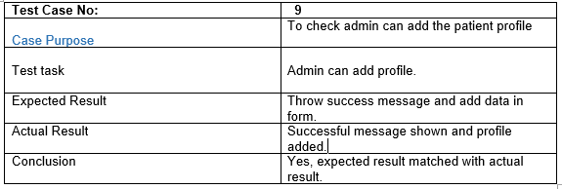

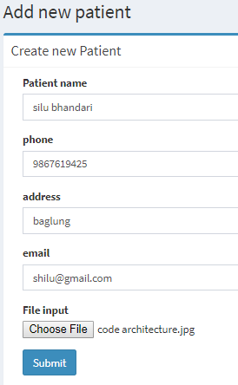

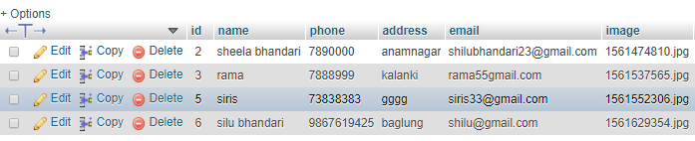



1. **Edit patient profile**

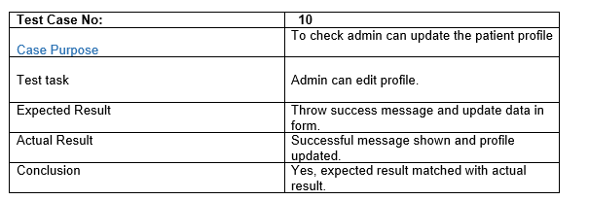

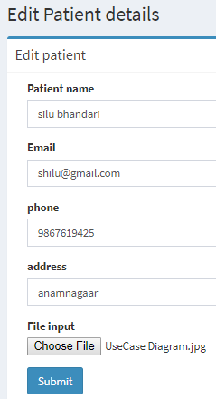

Address is updated

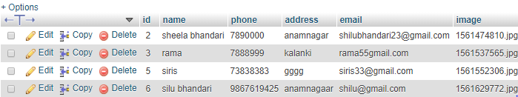



1. **Delete patient profile**

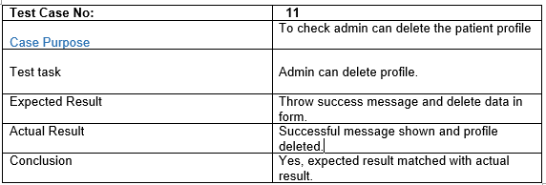

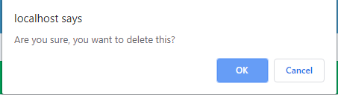

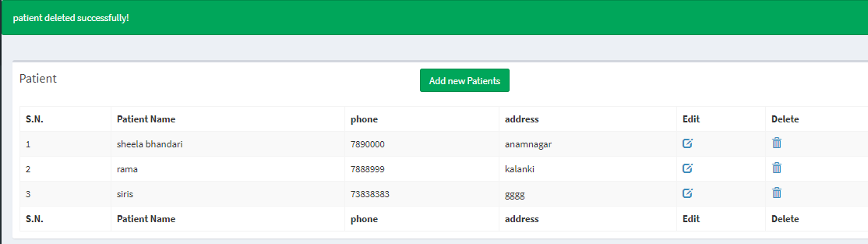



1. **Book Appointment**

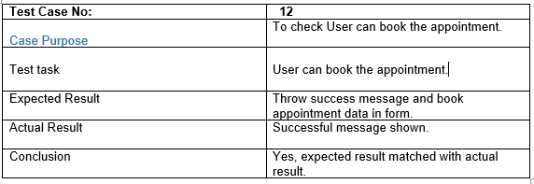

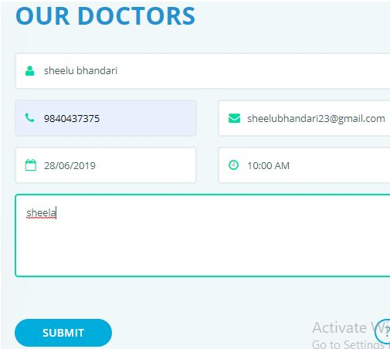

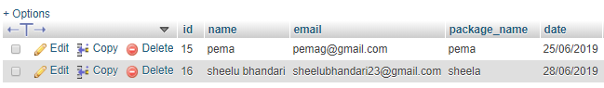



1. **Delete appointment list**

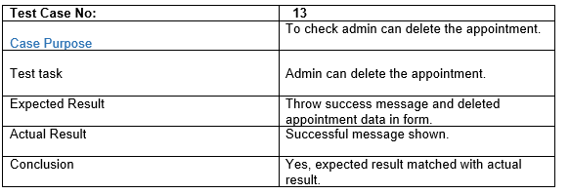

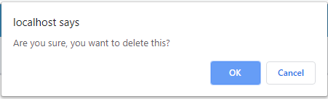

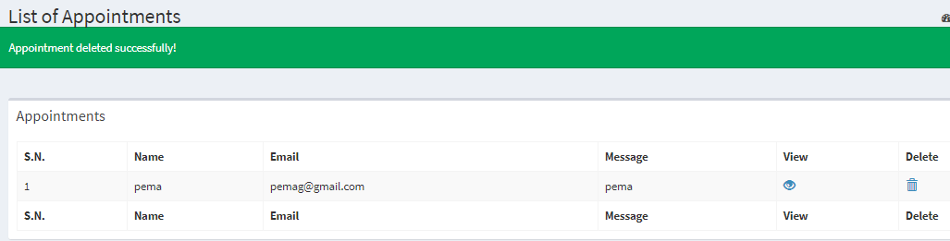

No data of sheelu

1. **Add doctor**

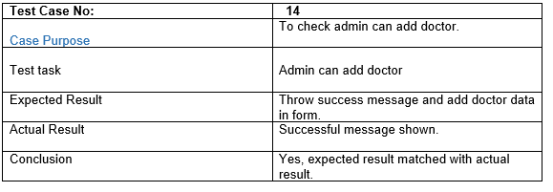

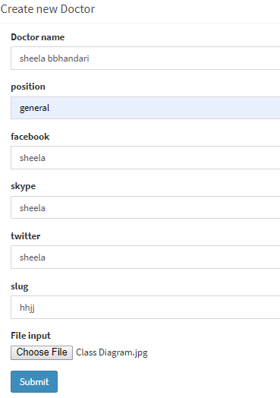

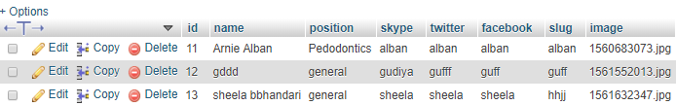



1. **Edit doctor profile**

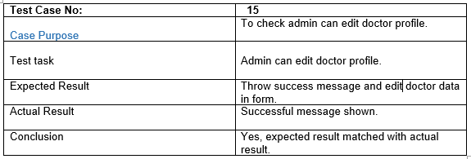

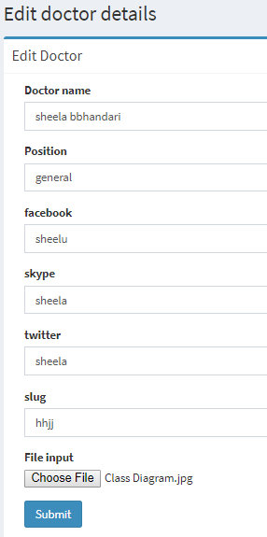

Facebook is updated



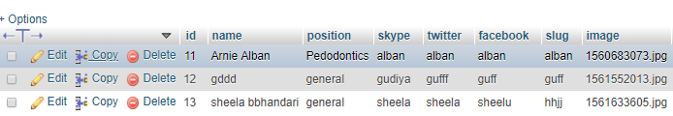

Updated data

1. **Delete doctor profile.**

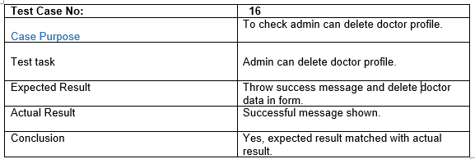

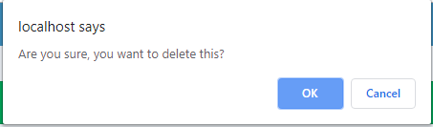

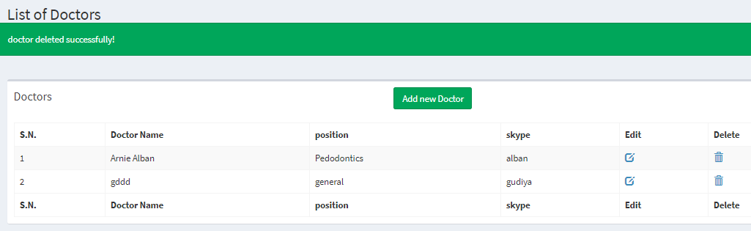

1. **User can contact us.**

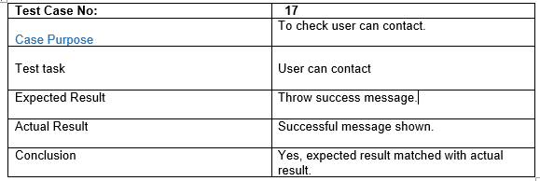

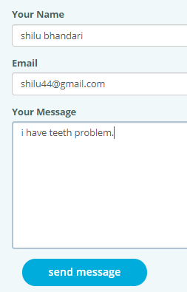

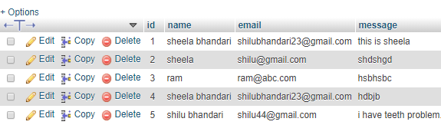

User name is successfully added.

1. **Admin can add the blogs.**

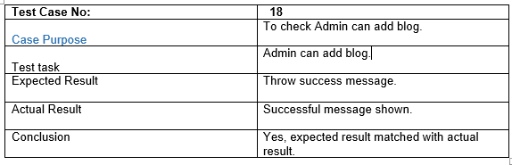

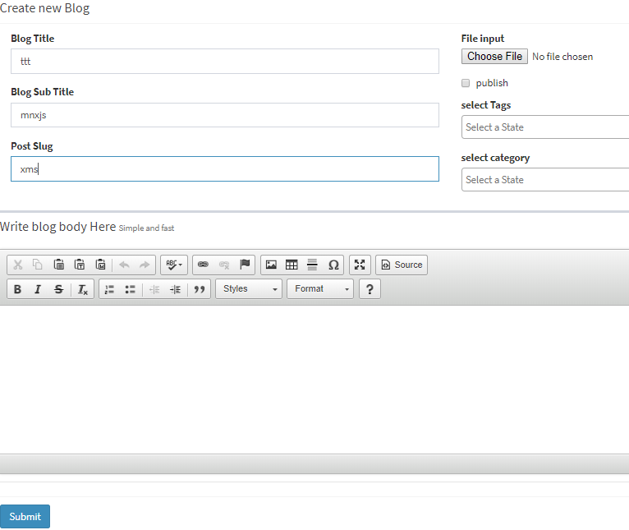

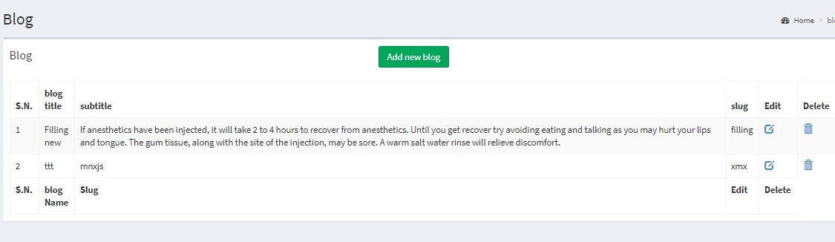

## 5.5 Unit Testing.

A software development process where units which is the lowest test of application is tested by Unit testing. It also determines the characteristics which perform the unit under test. Unit testing is often automated but usually can do manual way. (Rouse, 2016)

Following are the test plan for unit testing:

**Test Name: Register**

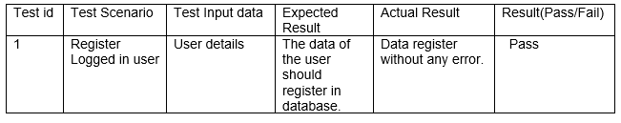

**Spec:**

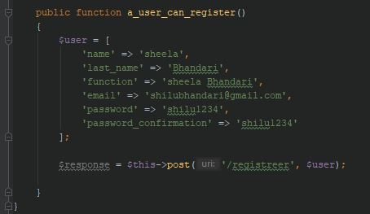

**Result:**

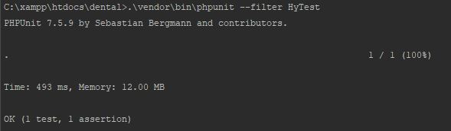

**Test Name: Login**

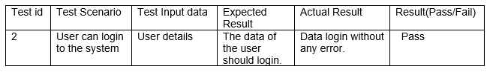

**Spec:**

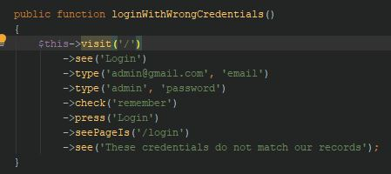

**Result:**



**Test Name: User can request a message to delete.**

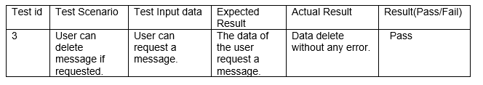

**Spec:**

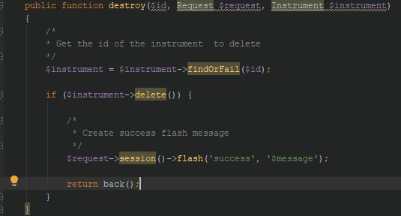

**Result:**



**Task Name: User can change password, if current password is correct.**

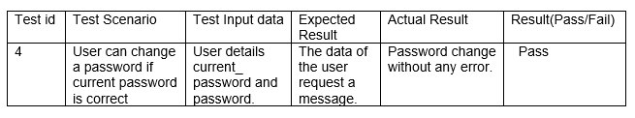

**Spec:**

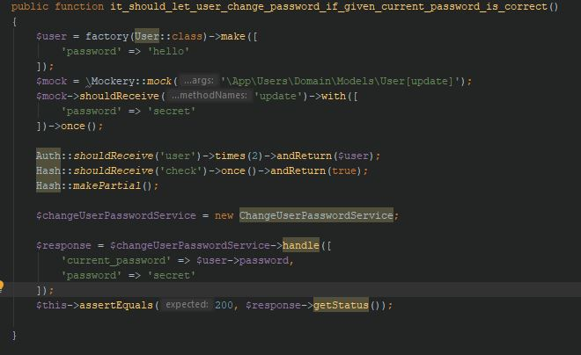

**Result:**



**Task Name: User can request a message to update.**

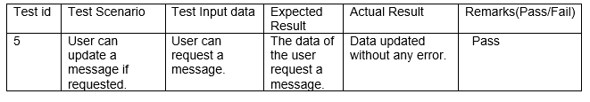

**Spec:**

# C:\Users\Shilu(Luri)\Desktop\Dentalclinic\Testing\update.JPG

**Result:**

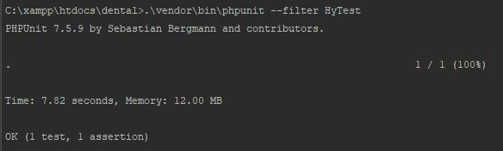

**Task Name: Login failed.**

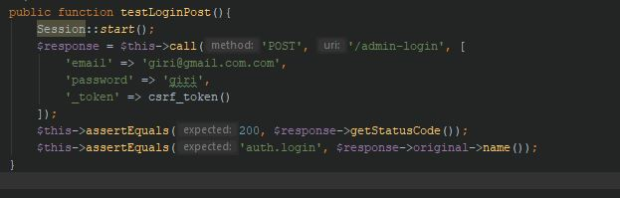

**Result:**

**C:\Users\Shilu(Luri)\Desktop\Dentalclinic\Testing\login fail 2.JPG**

# Chapter 6: Other Project Issues

## 6.1 Project Issues

I have faced many obstacles while developing a project. From beginning, requirement gathering to implementation many issues has been arises but I have overcome by providing relevant solution to make a project success.

Some issues arises while developing a project are:

1. While installing the laravel framework: By mismatching version errors and also installing composer, many issues has been shown. The solution is that I have updated latest version of Laravel composer.
2. Due to the unfulfilled requirements in a project, have some difficulties to interact with clients.
3. Have difficulties with interaction with database: I have to connect a database through command and I have no any idea about this. I have solved this problem by practicing from tutorial.
4. I have some problems during routing: For a web application, routing is used. I faced some problems to identified GET, POST request because of the unexperienced. I have solved this problems by practicing.

## 6.2 Risk Management

For every project, risk has been arises which causes the project failure. We didn’t overcome a risk in a time, we cannot reach a goal of a project. We cannot erase the risk but can overcome by providing an action. So, risk management is used for every project to reach a goal.

Risk management is the process of classifying possible threat, controlling threats then analyze risk of a project. It is a system used for preventing or reducing likelihood.

Following are the values of Likelihood**.**

|  |  |
| --- | --- |
| Likelihood | Values |
| Low | 1 |
| Medium | 2 |
| High | 3 |

Fig: risk likelihood

Following are the values of consequence.

|  |  |
| --- | --- |
| Consequence | Values |
| Very low | 1 |
| Low | 2 |
| Medium | 3 |
| High | 4 |
| Very high | 5 |

Fig: risk consequence.



|  |  |  |  |  |  |  |
| --- | --- | --- | --- | --- | --- | --- |
| SN | Risks | Likelihood | Consequence | Impact | Actions | Similar Risk |
| 1 | Natural disaster | 1 | 5 | 5 | Backup plan | No one |
| 2 | Bad Design | 1 | 4 | 4 | Training should be provided. | Due to this, I got a lot of problems. I have design many times. |
| 3 | Wrong  time estimation | 3 | 2 | 6 | Tasks should be divided on bases of timing | I have difficulties by wrong time estimation. I didn’t complete a task in time and allocated a lots of time. |
| 4 | Requirement does not meet | 1 | 3 | 3 | Planning should be done properly. | I have not gather the requirement correctly at the first. |
| 5 | Insufficient resources | 2 | 3 | 6 | Needed resources should be collected. | No one |
| 6 | Malware attack | 2 | 4 | 8 | Installation is required of anti-virus. | Data has been corrupted. |

Here, some risks has been arises but I have overcome by providing relevant risk management solution but in new future, risk can be increases.

## 6.3 Configuration Management

It is the discipline of ensuring that all the software and hardware assets which they known and can used to track at all times. It is an integral part of quality management at which delivered meets the specific criteria. It is a process of keeping files and folders in systematic order.

The importance of CM is to provide for the evaluation of changes including effects on technical and operational performance. CM should be fulfilled with detailed policies, procedures to maintain a version. [(Townsend, 2019)](CP%20proposal.docx#aa)

* Being established, configuration management is shown below in screenshot.

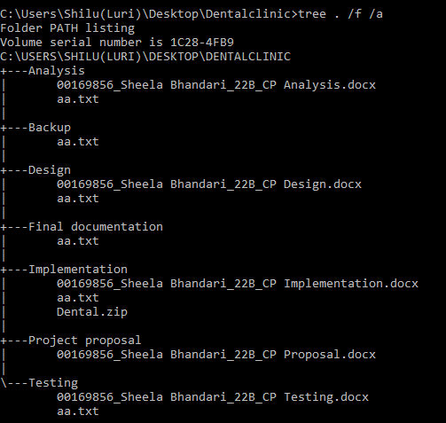

## 6.4 Scheduling and Gantt chart

Due to the internal and external factors our work sometimes, cannot be completed and not be according to the plan. Evaluation of our work is very important because it helps to learn and improve our future work.

Scheduling is mostly used for the development of a project. We don’t know how to clear the things of a project at the starting. So, we gather requirements and distributed each tasks into the various process time and completed every work of a project within time by the help of scheduling. It helps to manage a plan on the basis of the requirements.

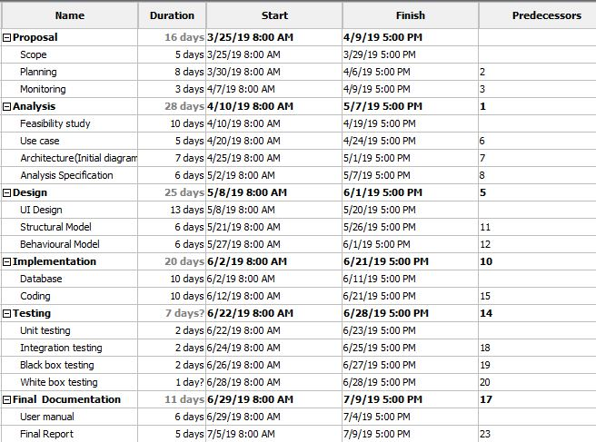

Figure 239: Scheduling

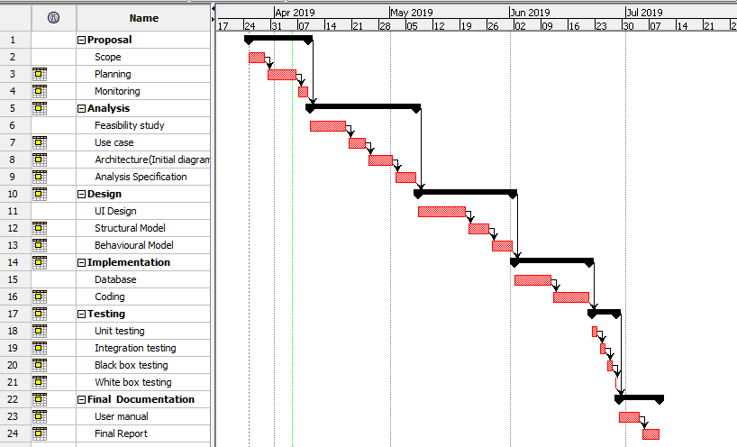

Figure 240: Gantt chart

## 6.5 Future Work

I have added important features in my project. But, due to the limited time, I can’t added extra functionality. In future, I would like to add extra features in a system such as:

1. Online payment system.
2. For the direct interaction with the seller, I would like to add online chat system.’
3. Function of accessibility.
4. Order accepted notification message.
5. Online view medicine details.

## 6.6 User Manual

User manual is used when user have some difficulties while finding information about the project. It provides the support to use particular system for people. So, I made a help page to guide a user’s for problem merely.

* The below screenshot after clicking help tab.

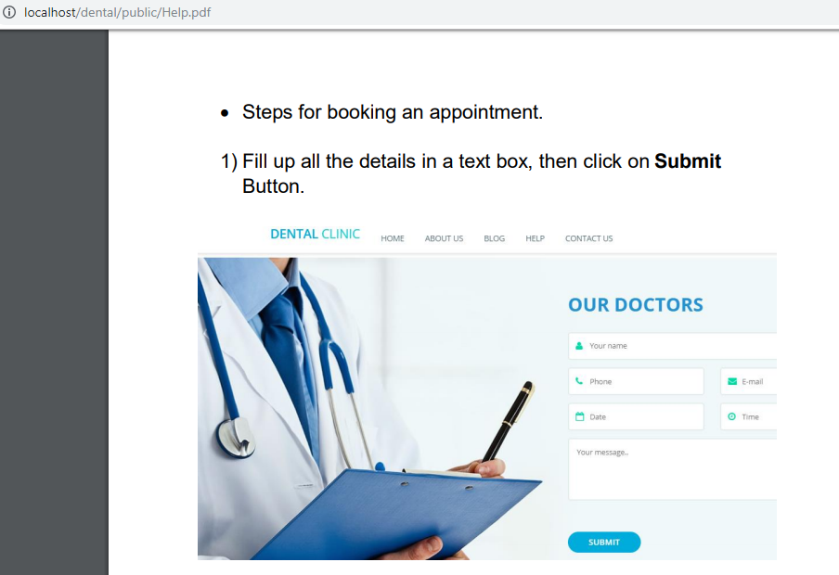

## 6.7 Limitation

Some Limitation of a project are:

1. Educated people only required and use to see this system.
2. Billing payment system is not provided through online.
3. Medicine can’t be seen through online.
4. Admin have to call to confirm their order acceptance.

# Conclusion

Finally, my project about Dental clinic management system has be completed. At the beginning of my project, I have gather the requirement techniques like observation, focus-group and brain-storming. Then, I have plan about the project and fix the time schedule for every task. I have chosen waterfall model methodology for the software development because my project is small and easy to understand. I have used MVC design pattern i.e. Model, View and Controller. Another phase is analysis. In analysis I have used PEST and CATWOE analysis and have done feasibility study. Then, I have distributed requirement into functional and non-functional requirement for the Moscow prioritization. Then I have design a use case diagram. After that I have done NLA and design initial class diagram.

Third phase is design. I have done class diagram and data flow diagram in structural design and activity diagram and sequence diagram in behavioral design. Then, I have design an ER diagram also disturbed database design. After then prototype is used where all the design of the clinic has been drawn, Fourth phase is implementation. I have used Laravel framework and PHP programming language for the project. MYSQL for the database and local host server is xammp. Fifth Phase is testing. I have done black box and Unit testing for the project. Sixth phase is other project issues which includes issues while developing a project, Risk Management, configuration management, scheduling and Gantt chart of the project, limitation about the project, future work of the project and user manual which helps user to find out more information about the clinic.

# Appendix

## Appendix1: Coding Screenshots:

* **Route**

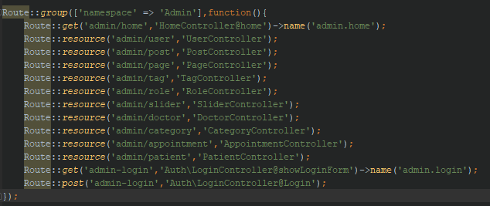

# 

* **Database connection**

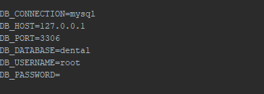

* **Header**

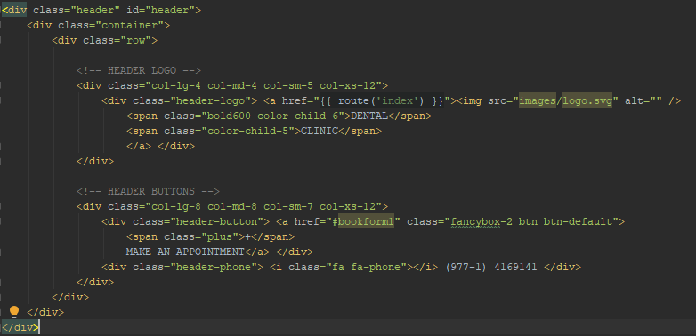

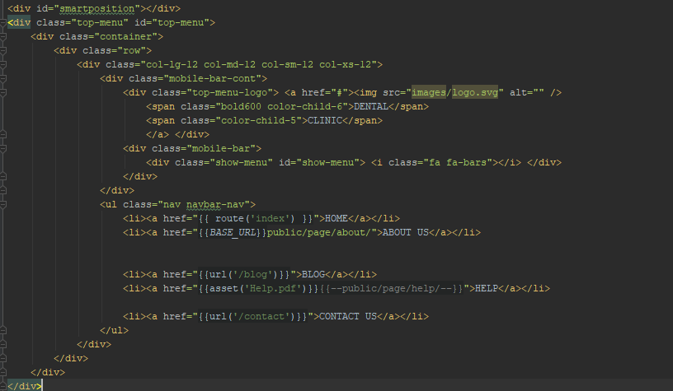

* **Footer**

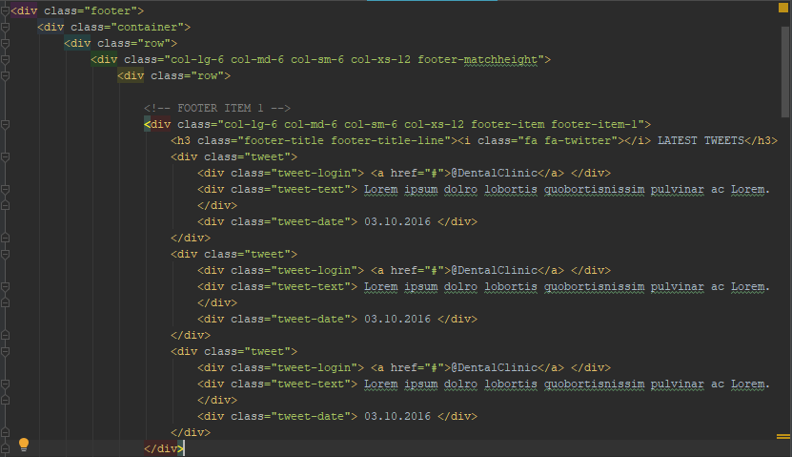

* **Home Controller**

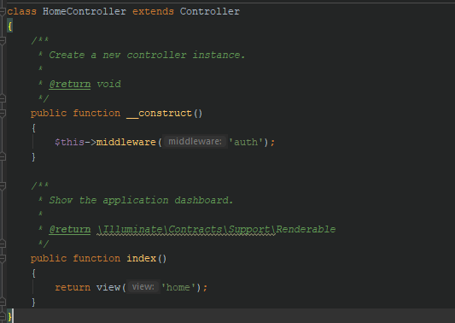

* **Login Controller**

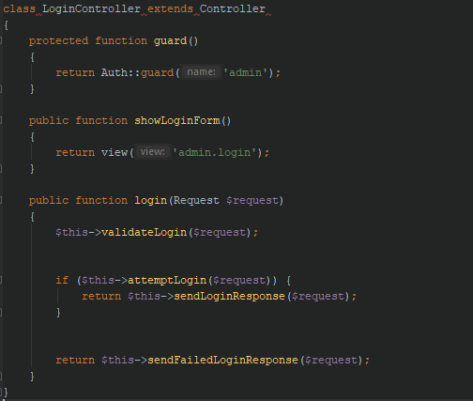

* **Signed in**

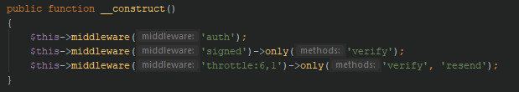

* **Logout**

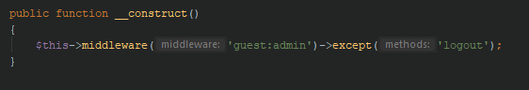

* **Appointment Controller**

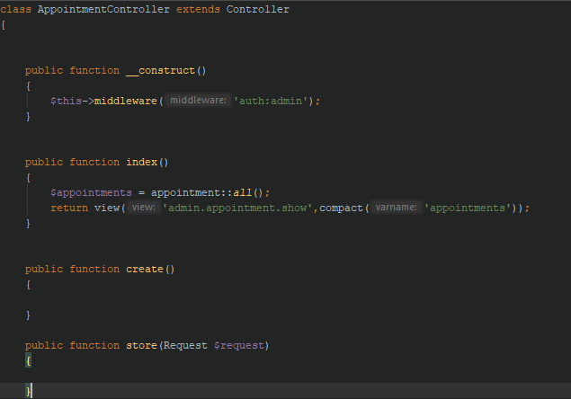

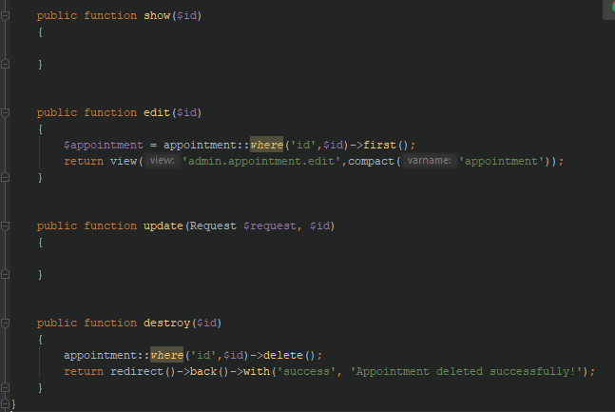

* **Doctor controller**

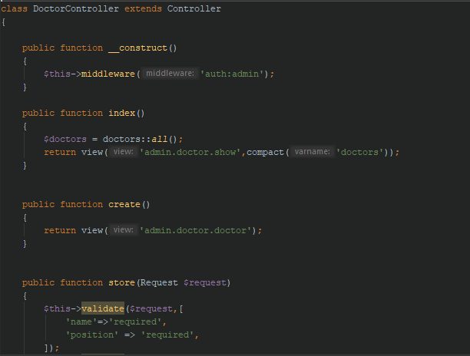

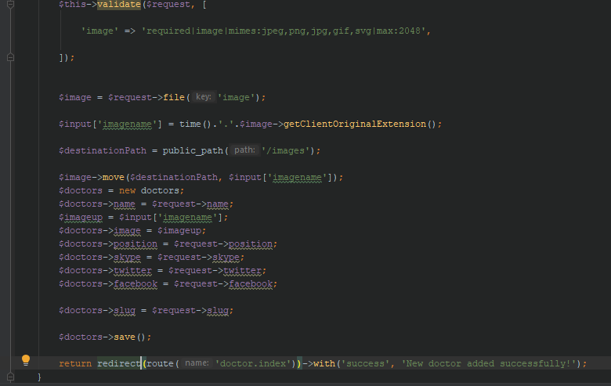

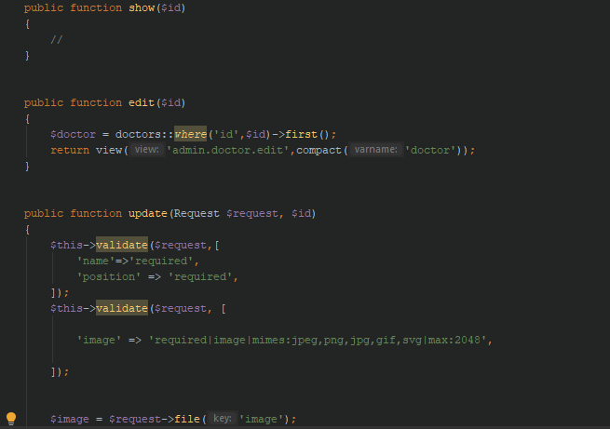

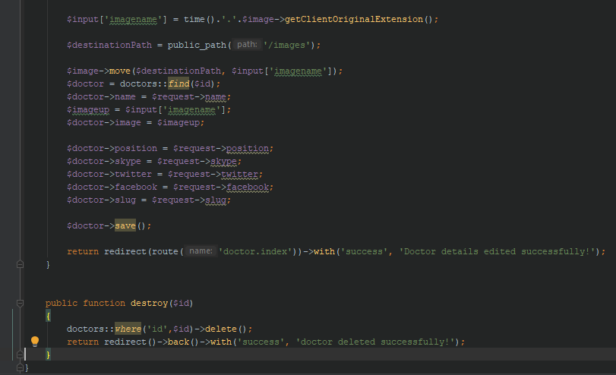

* **Patient Controller**

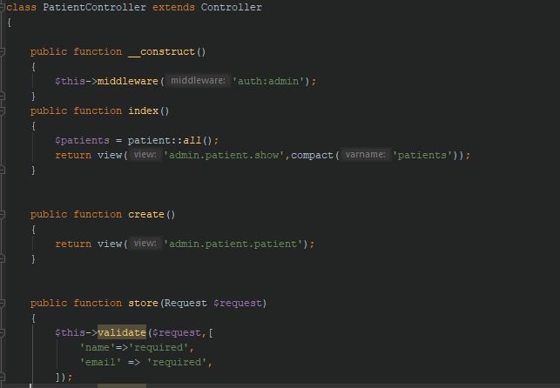

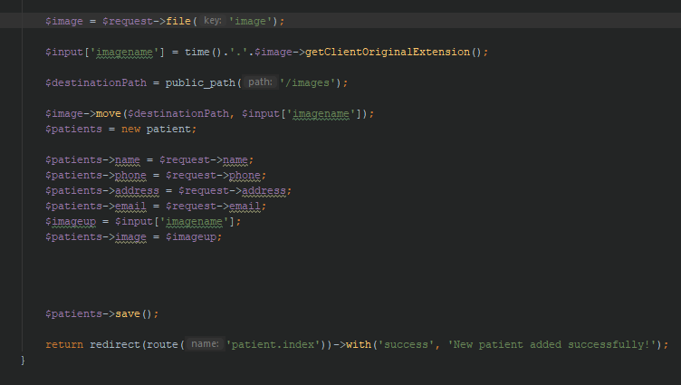

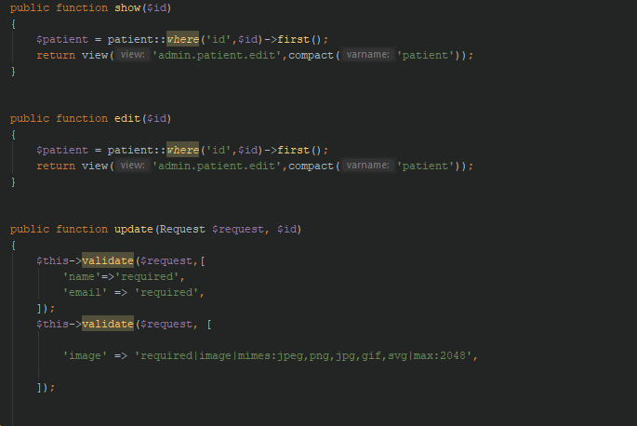

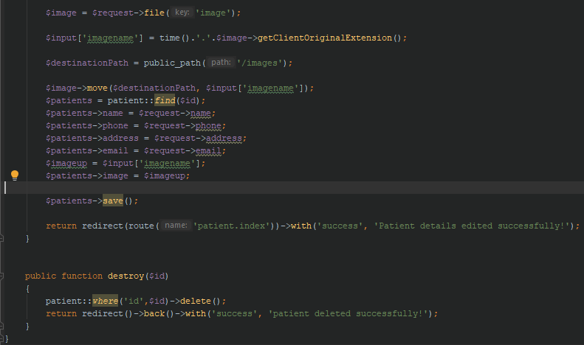

* **User Controller**

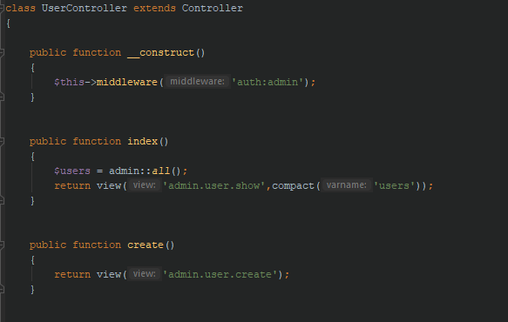

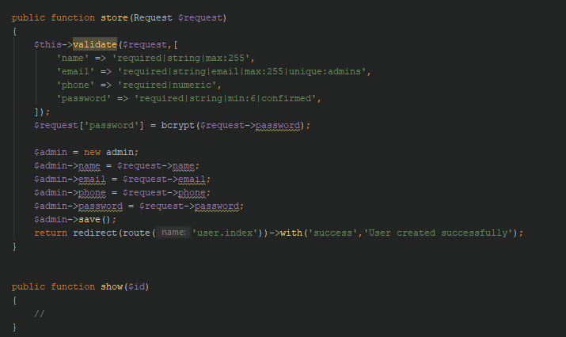

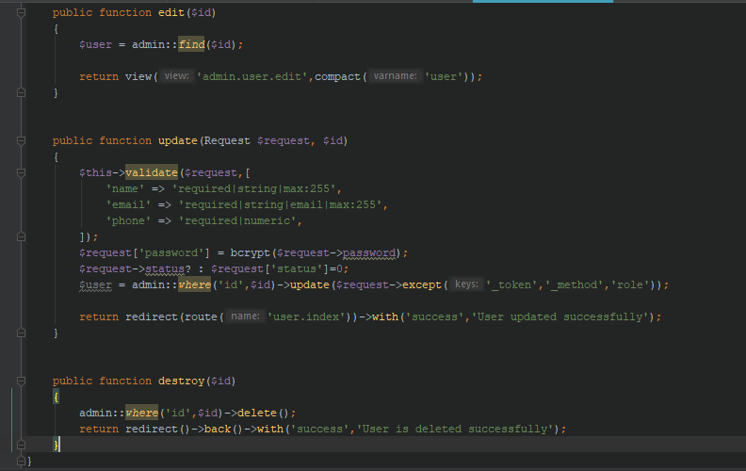

## User-Interface Screenshots

* **Home Page**

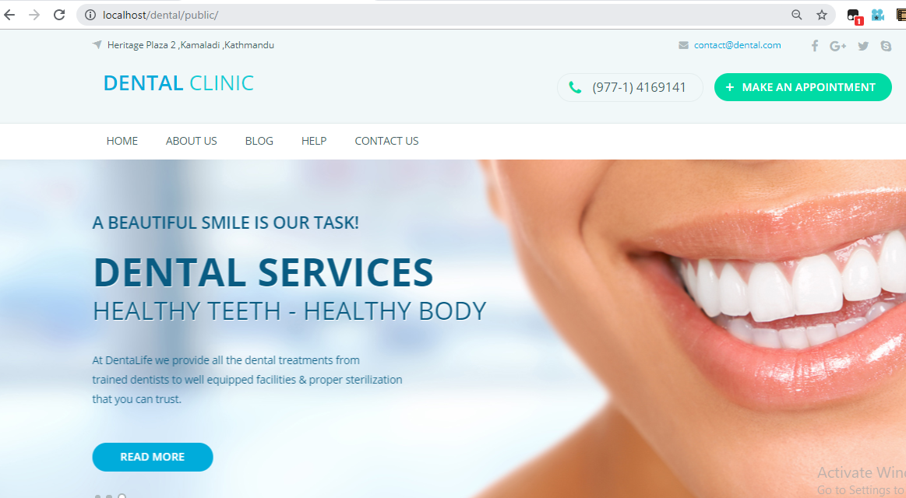

* **Book appointment**

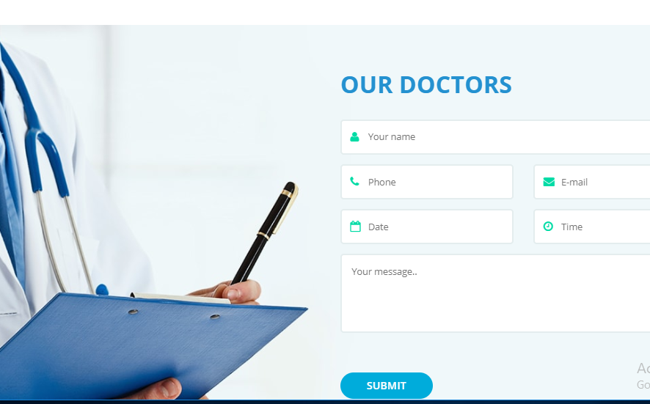

* **About Us Page**

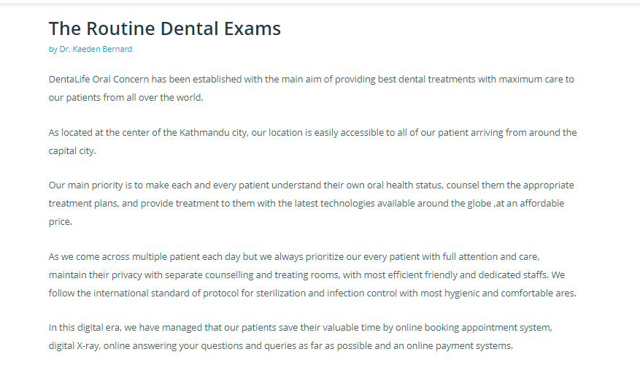

* **Contact Us Page**

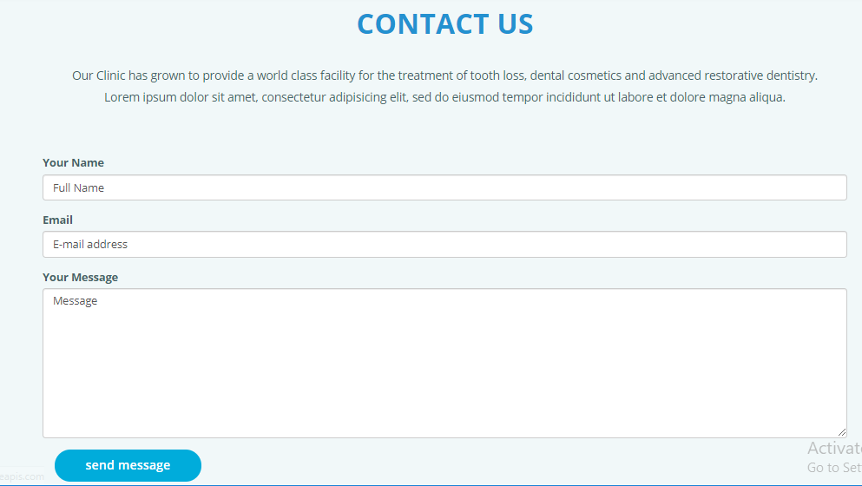

* **Admin Dashboard**

